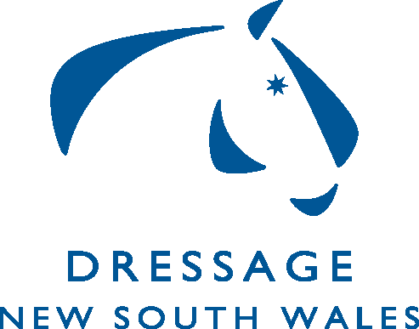**Expression of Interest**

**DNSW AOR High Performance Squad**

Initial squad selection will be self-nominated based on performances in the 2024 and 2025 competition seasons. Riders who achieve the qualifying scores within the time frame are invited to self-nominate for the squad. For more information go to the attached DNSW AOR HP squad guidelines document on the DNSW website.

|  |
| --- |
| Return: |
| **If you have any questions please contact Krystina Burdekin**  [krystina.burdekin@gmail.com](mailto:krystina.burdekin@gmail.com)  **Form must be signed and dated and returned via email to:** [admin@dressagensw.com.au](mailto:admin@dressagensw.com.au) |

|  |  |  |  |
| --- | --- | --- | --- |
| Personal Details: | | | |
| Name: | | Date: | |
| Street Address: | | | |
| Suburb: | State: | | Postcode: |
| Email: | | | |
| Mobile: |  | | |
| I am a financial member of DNSW | Yes / No / Unsure | | |
| EA Member No: |  | | |

|  |
| --- |
| Selection Criteria |
| Only combinations competing at elementary level and above will be considered for the HP Squad. Only Official competitive scores obtained at events from 2024/2025 will be considered for inclusion on the 2025 squad. Only one score with one judge can be included in the three nominated scores. Performance scores from State and National championships can be included regardless of the State they are held in.  **Elementary** – 3 scores of **over 68%** obtained at any official event.  **Medium**– 3 scores of **over 65%** obtained at any official event.  **Advanced** – 3 scores of **over 65%** obtained at any official event.  **FEI Small Tour –** 3 scores of **over 65%** obtained at any official event.  **Medium & Big Tour** – 3 scores over **65%** obtained at any official event |

|  |
| --- |
| Results |
| |  |  |  |  |  | | --- | --- | --- | --- | --- | | Horse | Event Name | Date | Level | % | |  |  |  |  |  | |  |  |  |  |  | |  |  |  |  |  | |  |  |  |  |  | |  |  |  |  |  | |  |  |  |  |  | |

## Signature …………………………………………………………………